Laboratory WORK REPORT №3

«Active filter circuits design and simulation»

**Principles of Circuits**

Student: CAO Xinyang

Program of Computer Science and Technology

group CS

Name Surname

# Work purpose: to study parameters of Active Filters and basis of active filters circuits design

Goals:

1) Design an active filter on the basis of operational amplifier «Sallen-Key»

2) Simulate active filter scheme and analyze dependencies of output voltage and resistor and capacitor values tolerance.

3) Analyze frequency domain of filter and determine approximation type and bandwidth

4) Analyze time domain of filter and which of test signals has passed in bandwidth

5) Analyze step response and H0/Hc value

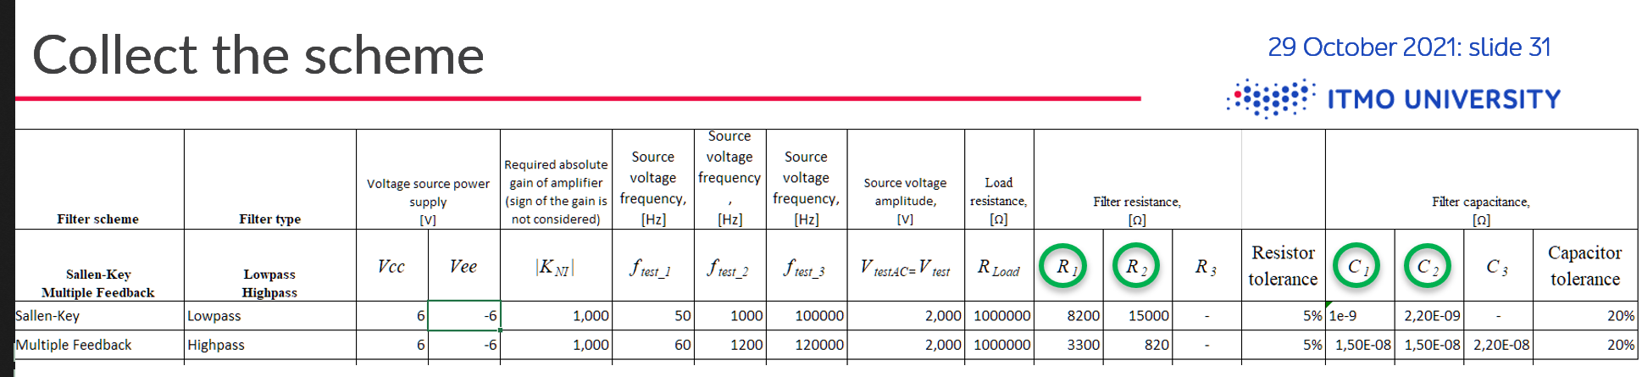

# Starting data

* **Required gain of amplifier $K_{NI}=$** 1
* **Required resistor tolerance $:{Tol}_{R}=$**1%
* **Required capacitor tolerance $:{Tol}_{C}=$**2%
* **Operational Amplifier : Sallen-Key**
* **Voltage source power supply** Vcc $=4.5$ (V) / Vee $=-4.5$ (V)
* **Frequency for time domain simulation**

$f_{test1}=800$ (Hz)

$f_{test_{2}}=$ 12000 (Hz)

$f_{test_{3}}=$ 420000 (Hz)

* **Test signal voltage magnitude**

$V_{test_{AC}}=V_{test}=1.5$ (V)

$V_{step}=1$ (V) (for any variant)

* **Resistor parameters**

$R_{1}=7870$ (Ω)

$R_{2}=14700$ (Ω)

$R_{3}=-$ (Ω)

$C_{1}=10$ (nF)

$C_{2}=22$ (nF)

$C_{3}=-$ (F)

$R_{Load}=$ 1000000 (Ω)

* **Amplifier scheme : Sallen-Key**
* **Filter type: Low-pass**

# Simulation

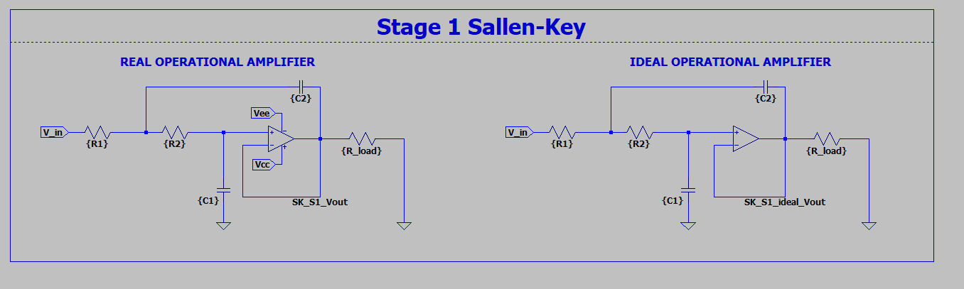

Figure 3.1 – Sallen-Key Low-Pass filter

## Filter evaluations:

## Time domain simulation results

### $f_{test_1}=800$ (Hz)

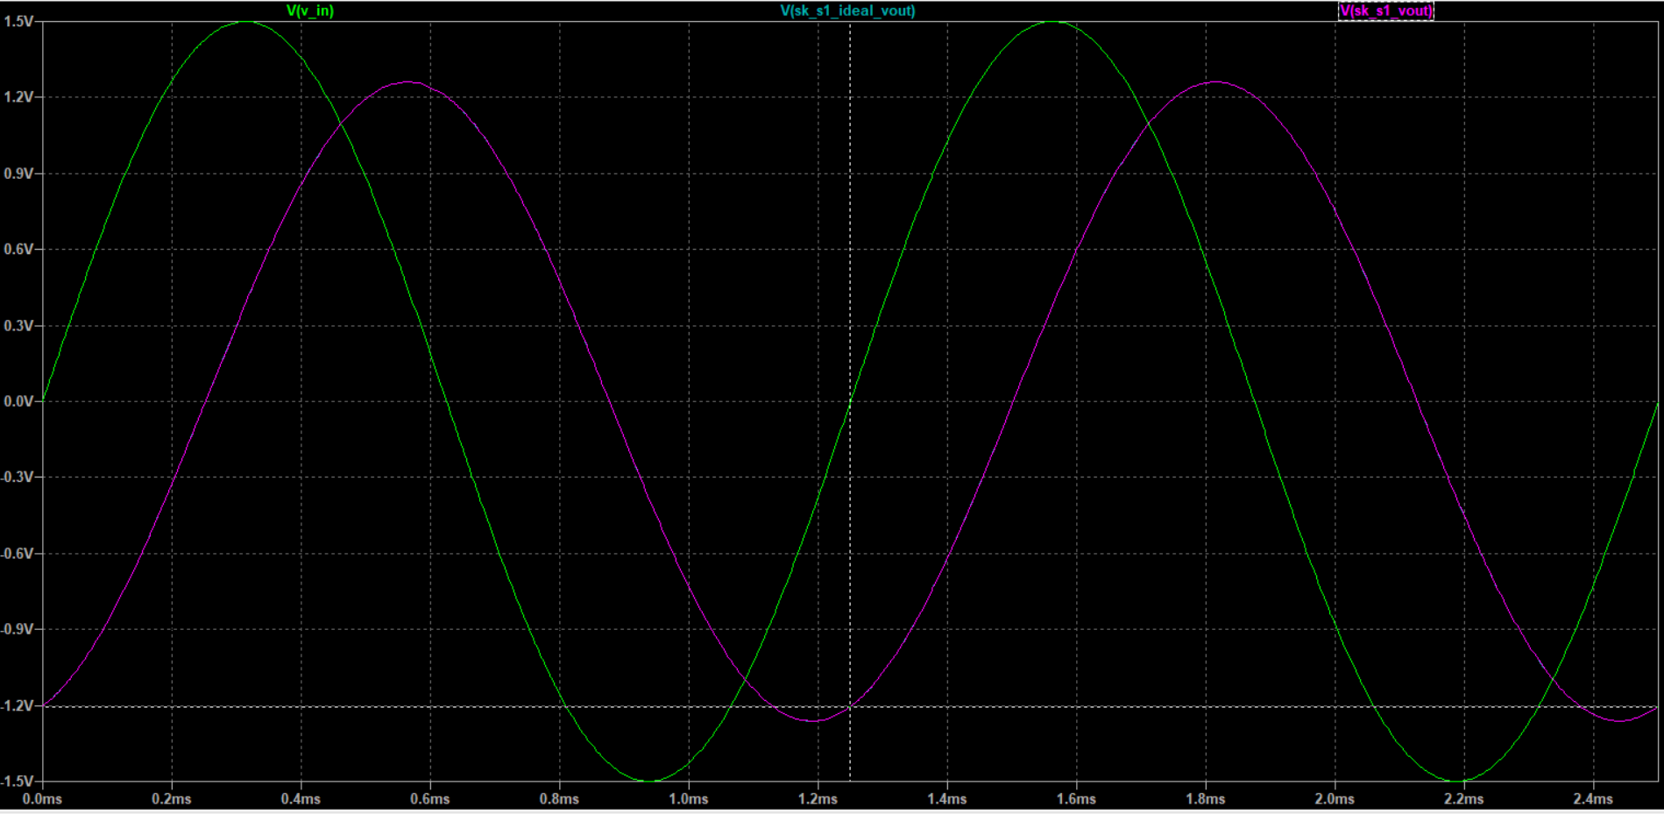 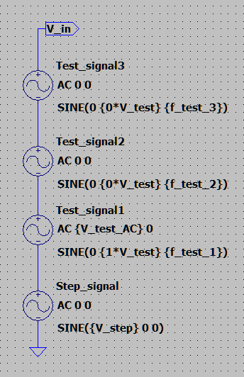

Figure 3.2 – Input and output voltages of ideal and real operational amplifiers active filters

$f_{test_1}=$ $800$ (Hz)

### $f_{test_2}=12000$ (Hz)

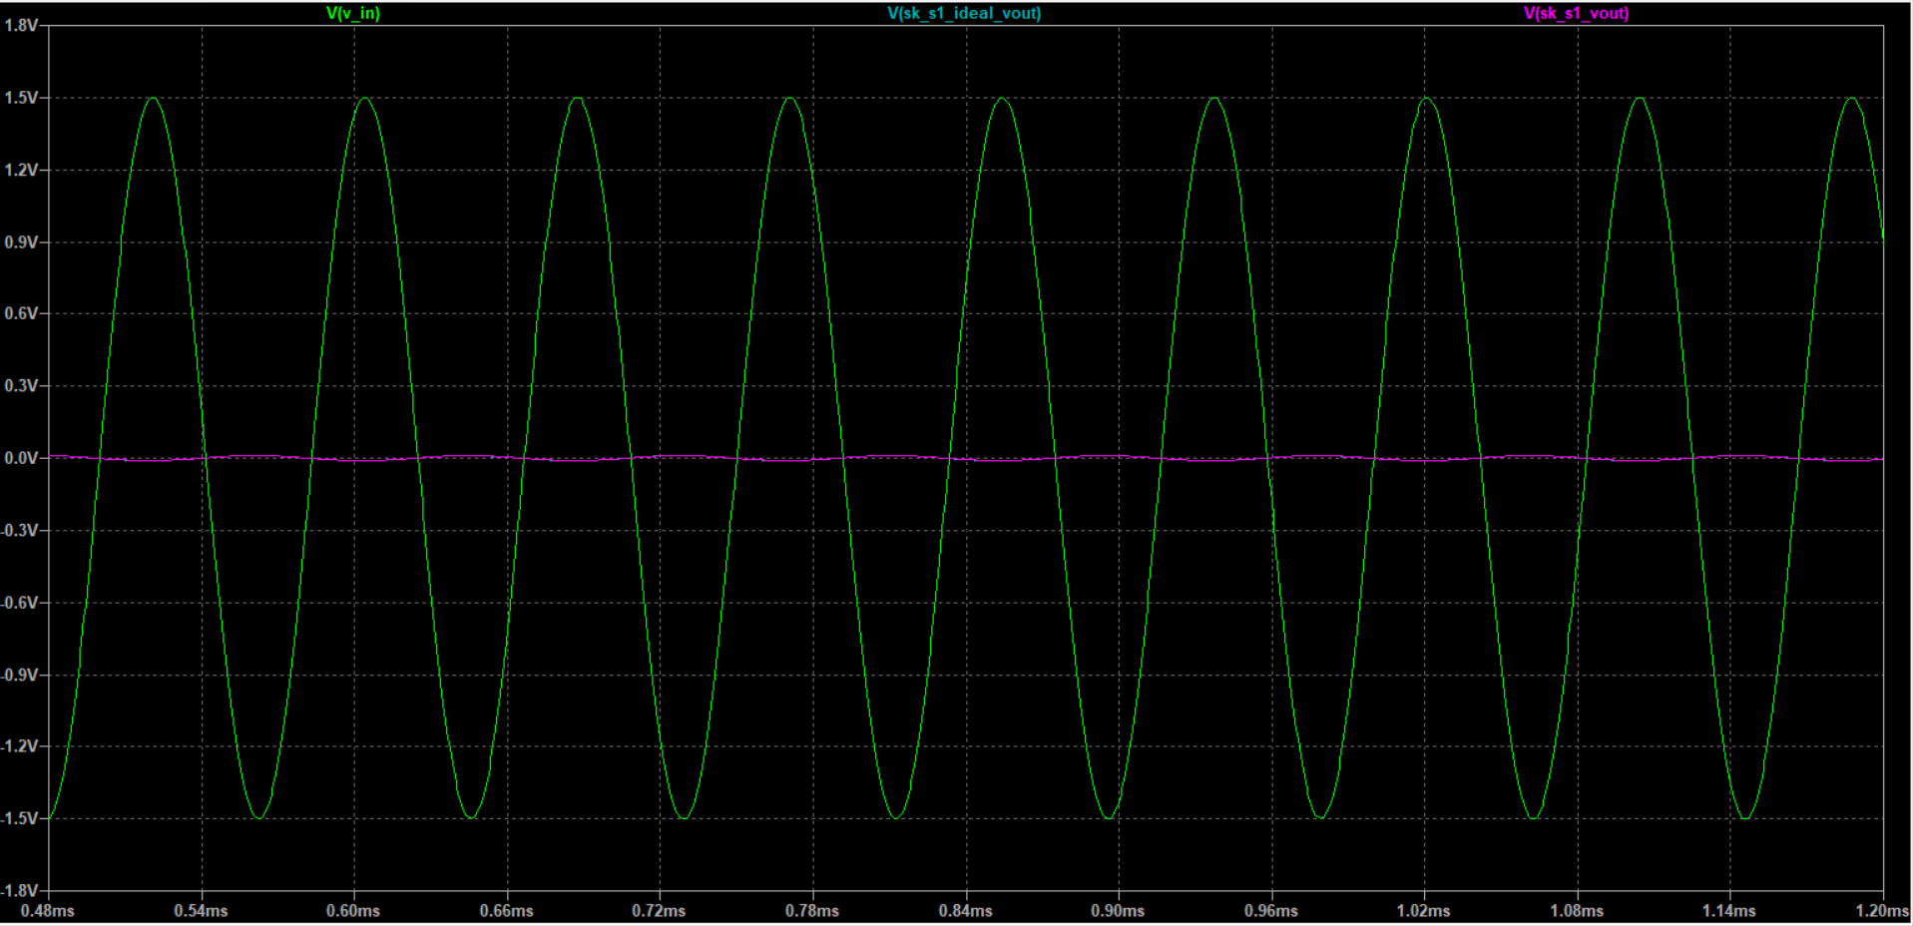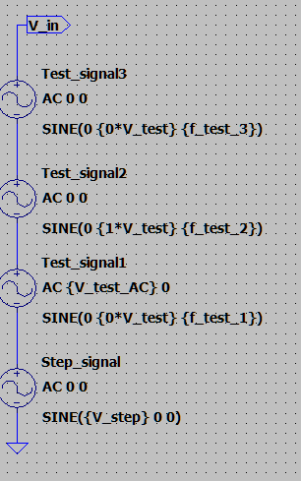

Figure 3.3 Input and output voltages of ideal and real operational amplifiers active filters

$f_{test_{2}}=$ 12000Hz,

### $f_{test_3}=420$ (kHz)

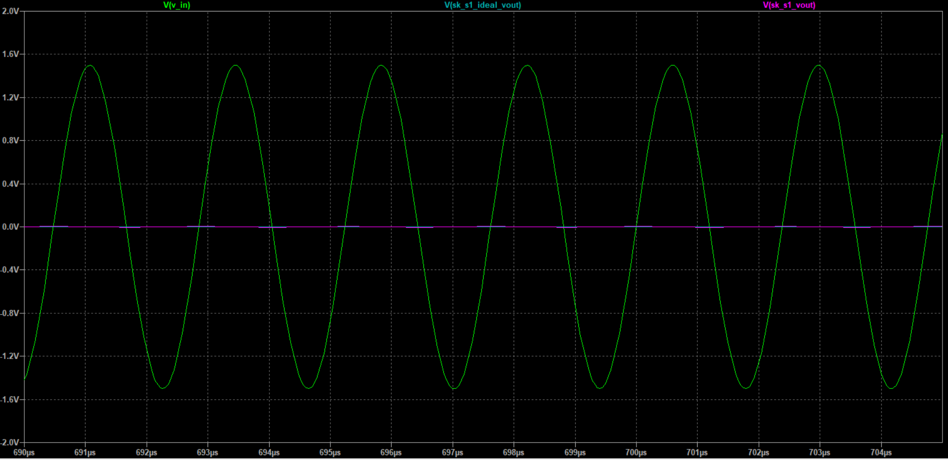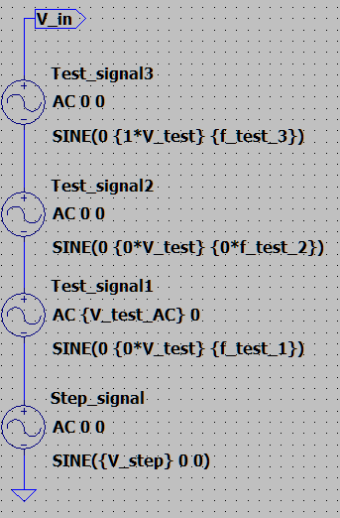

Figure 3.4 – Input and output voltages of ideal and real operational amplifiers active filters

$f_{test_3}=$ $420$ (kHz)

$Step response check$

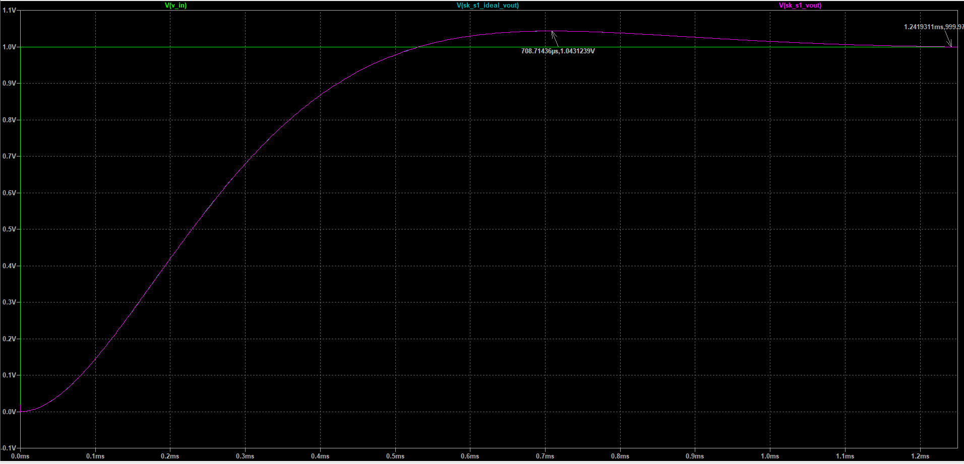

Figure 3.5 – Step response of ideal and real operational amplifiers active filters

## Frequency domain simulation results

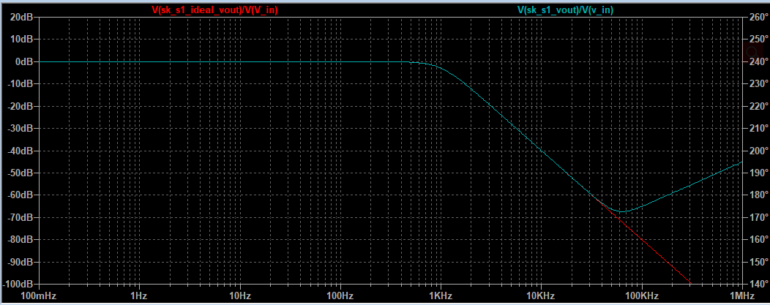

Figure 3.6 – Input and output voltages of ideal and real operational amplifiers active filters

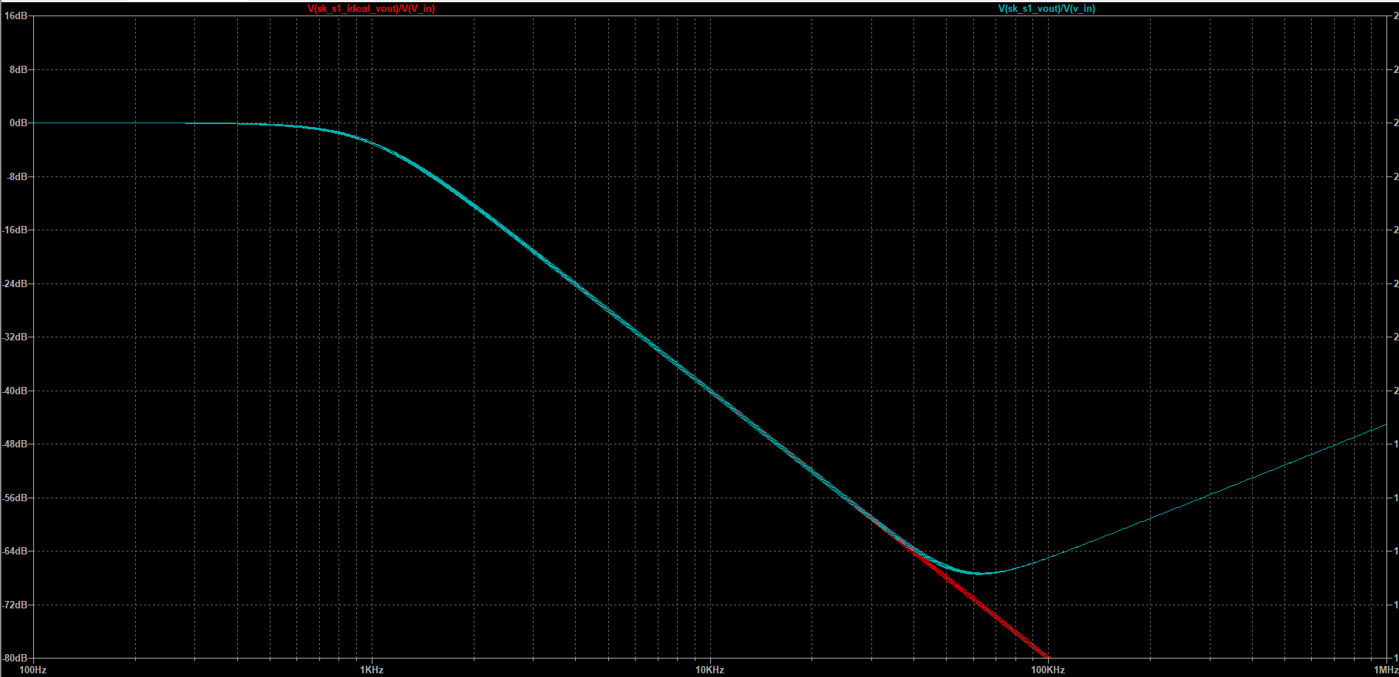

Figure 3.7 – Capacitor tolerance effect on the filter parameters

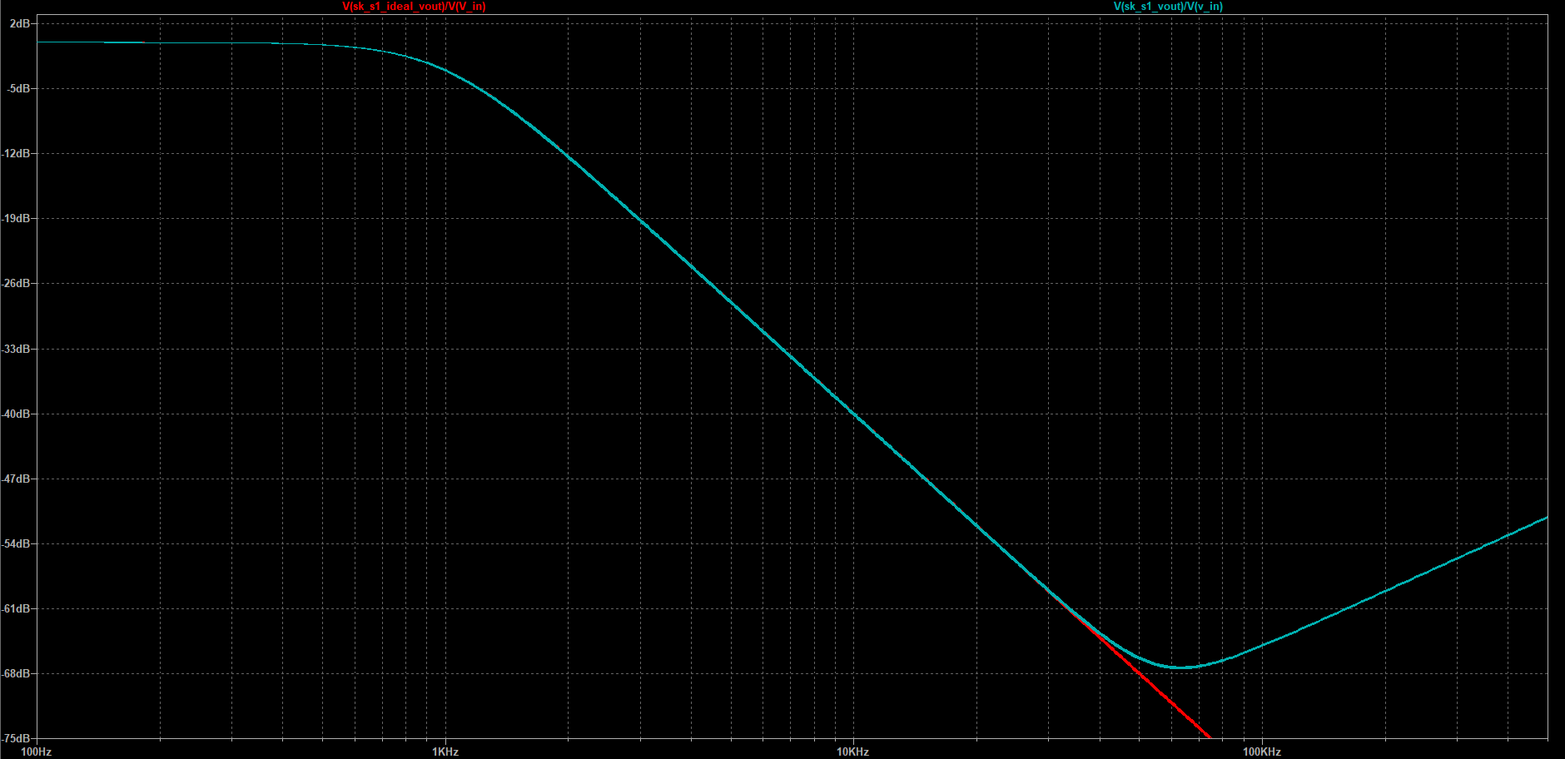

Figure 3.8 – Resistor tolerance effect on the filter parameters

Table 1. Parameters of the filter

|  |  |  |  |
| --- | --- | --- | --- |
|  | Description | Filter type: lowpass Butterworth | |
| nominal | tolerance range |
| R1, (Ω) |  | 7870 | 7791.3-7948.7(±1%) |
| R2, (Ω) | 14700 | 14553-14847 |
| R3, (Ω) | - | - |
| С1, (nF) | 10n | 9.8n - 10.2n |
| С2, (nF) | 22n | 21.56n - 22.44n |
| С3, (nF) | - | - |
| fc | Frequency at -3dB gain level of the passband (resistor tolerance), fig. 3.7 | 1.009kHz | 0.9-1.1kHz |
|  | Frequency at -3dB gain level of the passband (capacitor tolerance) fig. 3.8 | 1.019kHz | 0.9-1.1kHz |
| K | Gain | 1,0000 | 1,0000 |
| H0/Hc | Gain ripple in the passband (-3.0dB) | 0.14 | 3.14dB |

# Conclusions

Which filter type were used?

Sallen-Key Low-pass filter.

What was the bandwidth?

Bandwidth is the difference between the limiting frequencies.

Which test signals (test 1, 2 or 3) were passed the filter?

Signal **test1** passed the filter.

What was the maximum/minimum gain relation in the passband?

Pass band attenuation: it is limited between specified values. Which circuit, such as filter or telephone circuit, does not allow signals to pass through, or the attenuation is higher than the required stop band attenuation level.

Pass band gain: the frequency response of the circuit is the same as that of the circuit passive filter, except that the amplitude of the signal increases the value of the pass band voltage gain of the gain amplifier and the perforated in-phase amplifier.